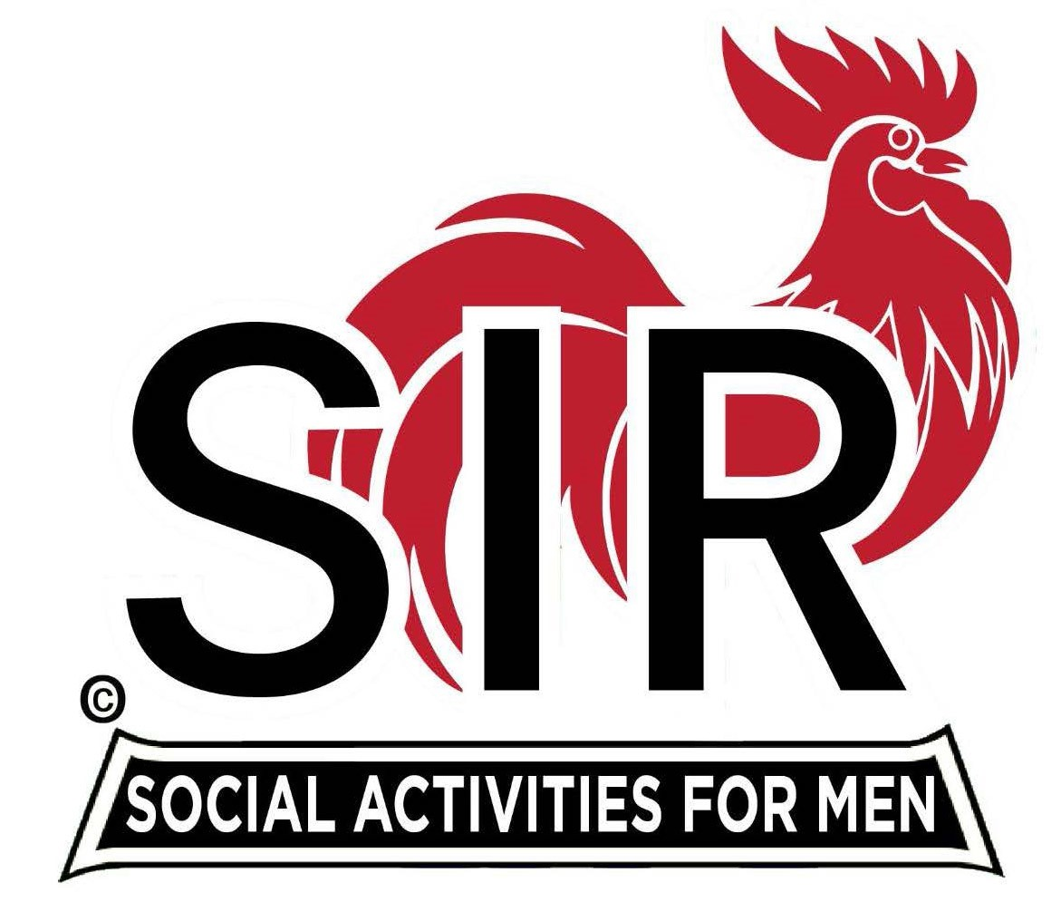
Las Trampas Branch 116
BEC Meeting Agenda
November 20, 2023, 9:15 AM at Boundary Oak
The Mission of SIR is to enhance the lives of our members through fun activities, events and luncheons while making friends for life.

9:15 am Call to order; Secretary, Paul Ramacciotti – Confirm quorum and
Approval of October16, 2023 BEC meeting minutes

9:20 am Standing Reports

- Treasurer – Jeff Johnson, Charlie Guthrie

- Treasurer’s Report

- Luncheon Report – Mike Schneider, Dennis Snarr

- November 20, Boundary Estimated Count

- Membership – Phil Goff

4. RAMP Department Head Reports:

- Recruitment – Don Schroeder
- Activity Coordinator – Mike Ward
- Member Relations - Michael Barrington
- Publicity – Paul Russell (AI & SIRs)

9:40 am Little SIR Updates – Alan Pope

- Speaker Info – Mark Triska
- Birthday Boys – November

9:50 am Updates & New Business

- Recruiting Ideas – Jeff Johnson
- Home Visit – Rob Lemmo
- Farmer’s Market Update – Roger Craig
- Holiday Party Update - Committee

10:15 am Adjourn: Lunch Preparations

